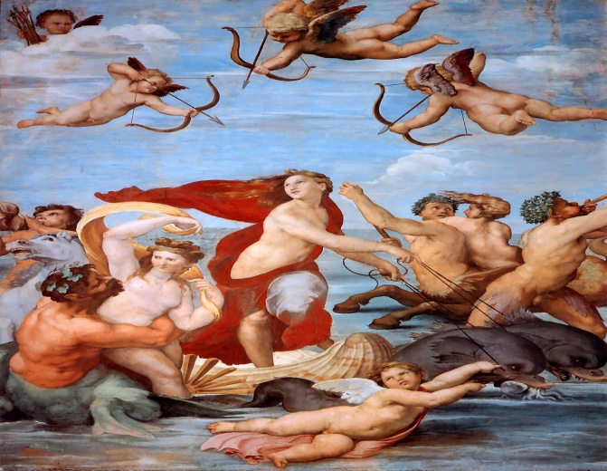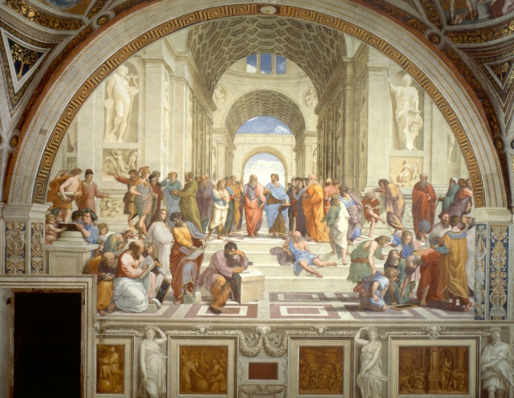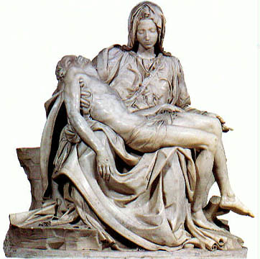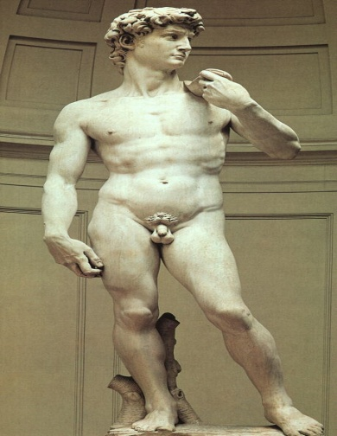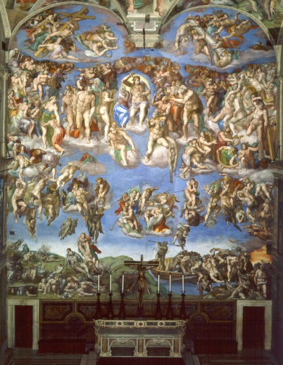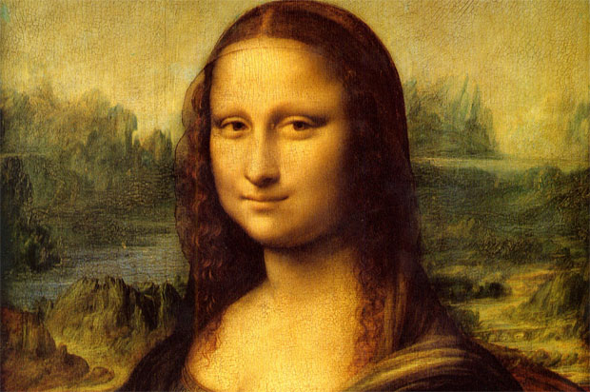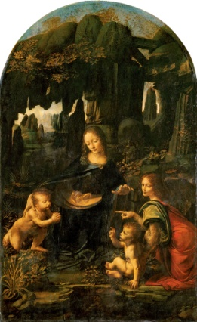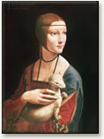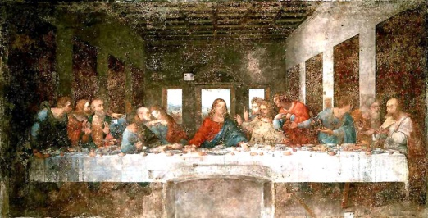

Triumph of Galatea - Raphael Sanzio

School of Athens - Raphael Sanzio

Pieta - Michelangelo Buonarroti

David - Michelangelo Buonarroti

The Last Judgment - Michelangelo Buonarroti

Mona Lisa - da Vinci

Virgin of the Rocks - da Vinci

Chiaroscuro - da Vinci

Last Supper - Leonardo da Vinci

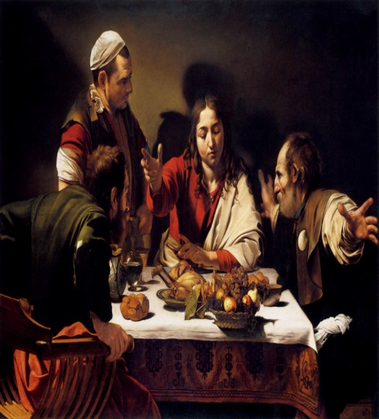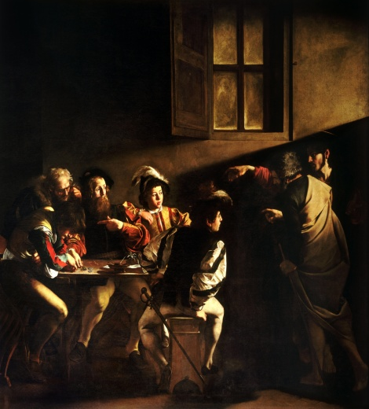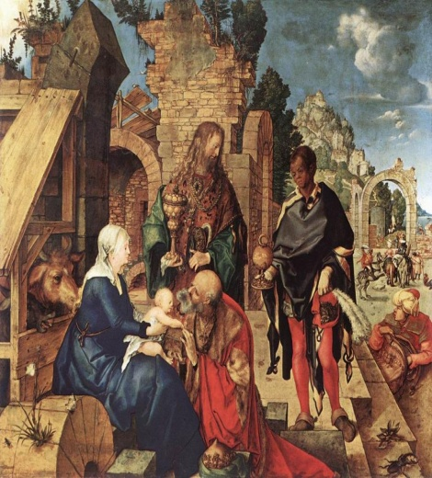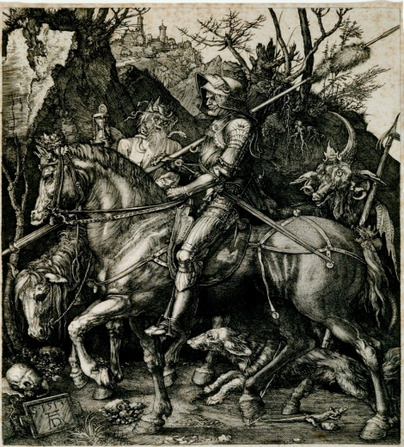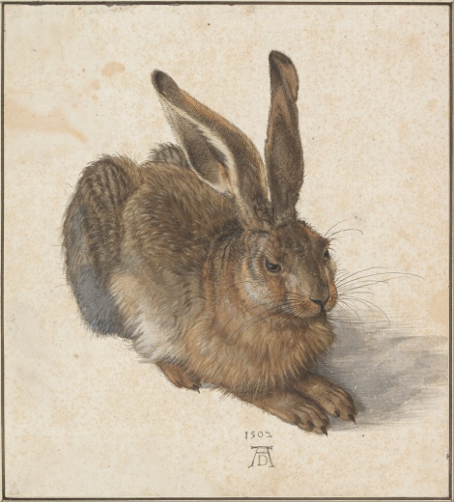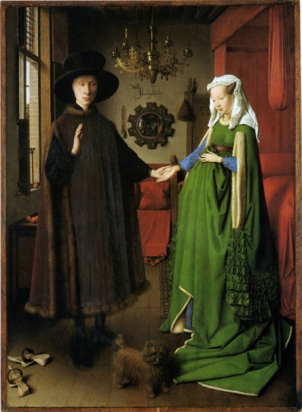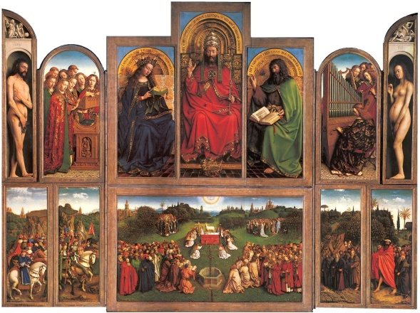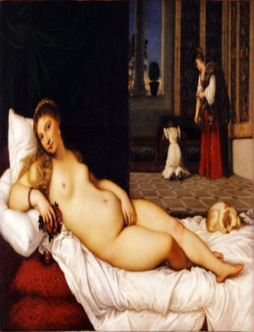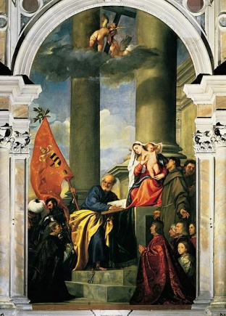

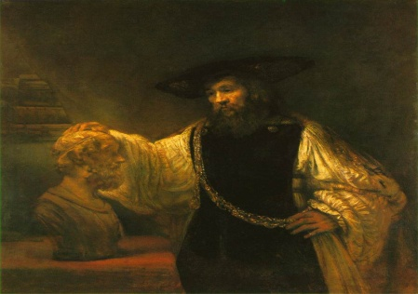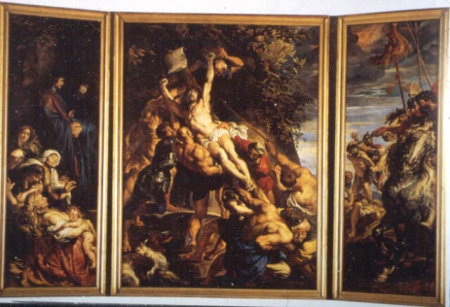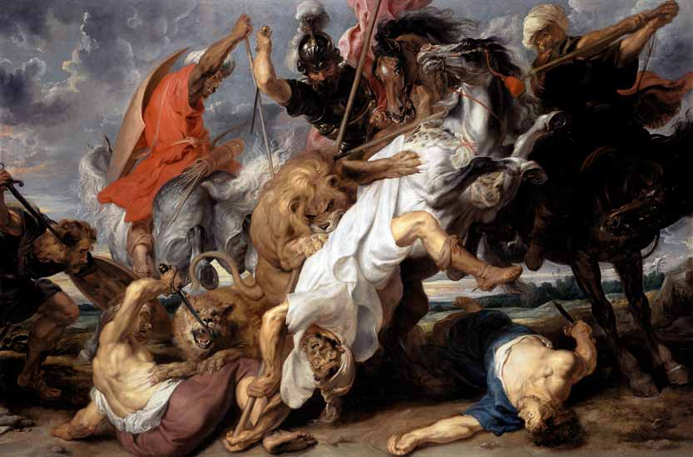  
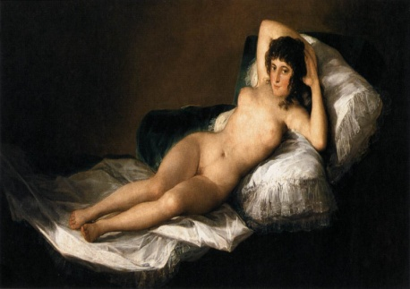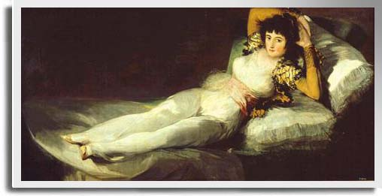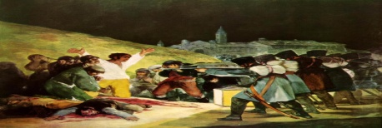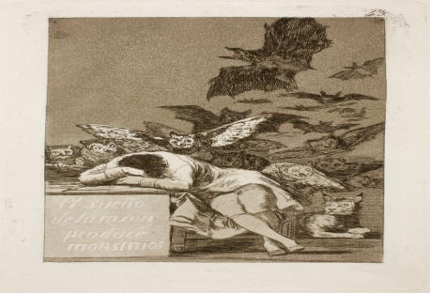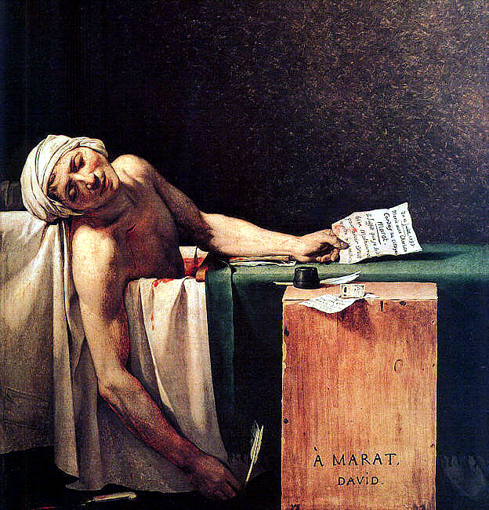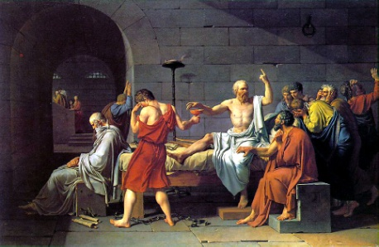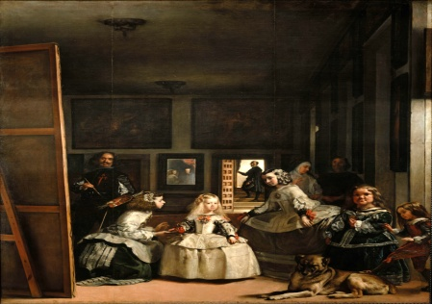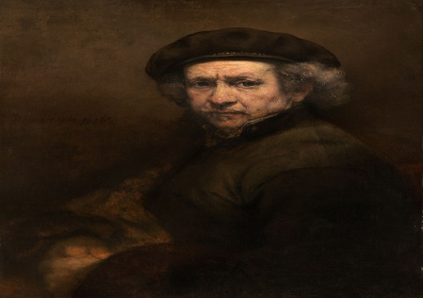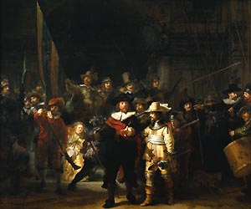’

Supper at Emmaus - Carvaggio

Calling of St. Matthew - Carvaggio

Adoration of the Magi - Albrecht Durer

Knight Death and the Devil - Albrecht Durer

Young hare - Albrecht Durer

Arnolfini Wedding - Jan Van Eyck

Ghent Altarpiece - Jan Van Eyck

Venus of Urbino - Titian

Pesaro Altarpiece - Titian

The Nude Maja - Francisco Goya

The Maja - Francisco Goya

The Third of May - Francisco Goya

Los Caprichos - Francisco Goya

Death of Marat - Jacques Louis David

Death of Socrates - Jacques Louis David

Las Meninas (The Maids of Honor) - Diego Velazquez

Self Portrait - Rembrandt van Rijn

Night Watch - Rembrandt van Rijn

Aristotle - Rembrandt van Rijn

Raising the Cross - Peter Paul Rubens

Lion Hunt - Peter Paul Rubens

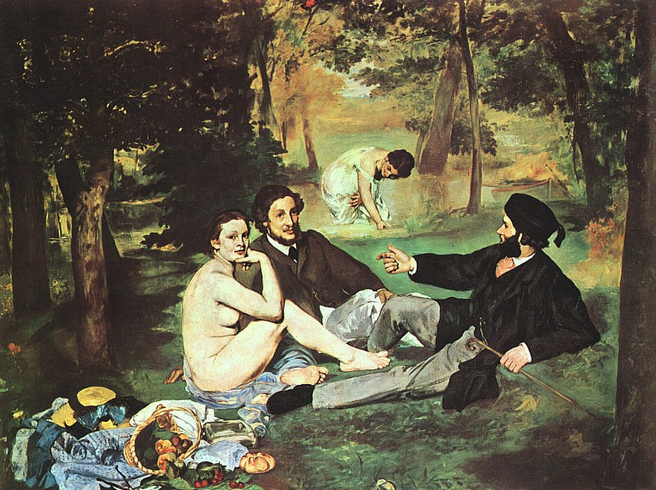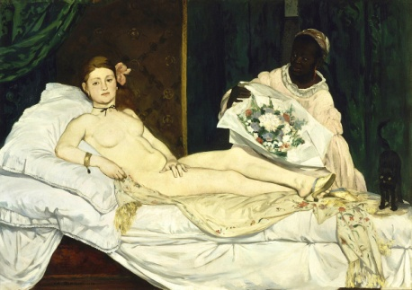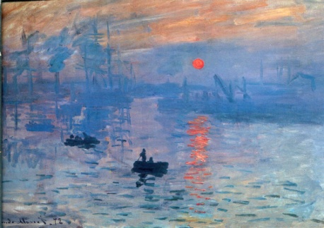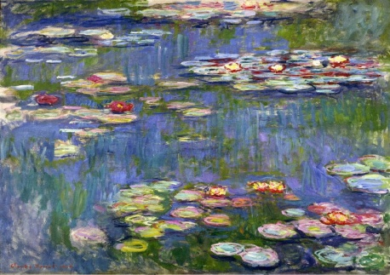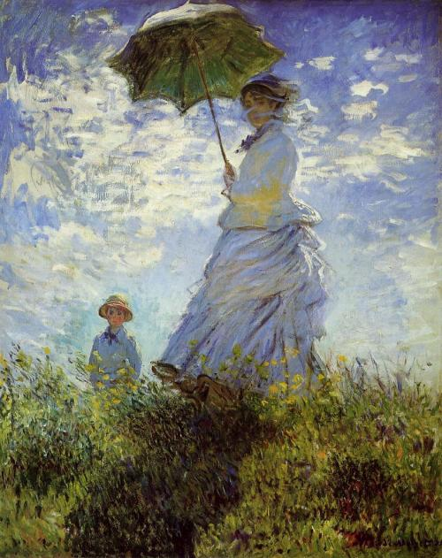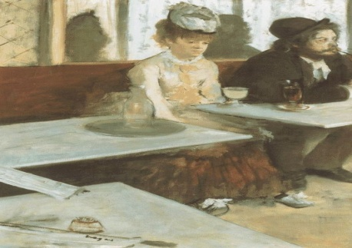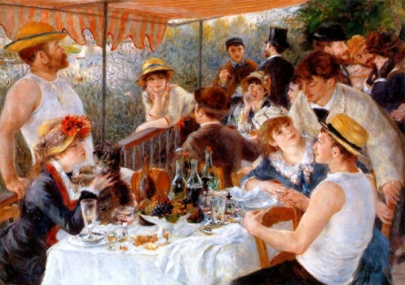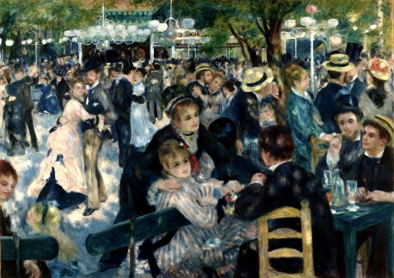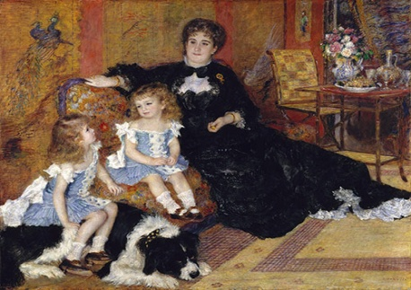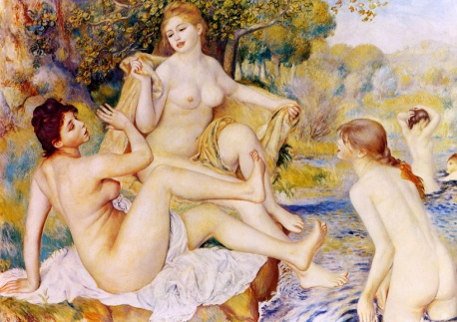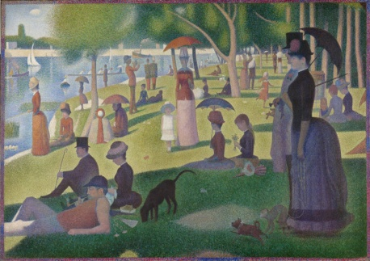

Olympida -Edouard Manet

Luncheon on the Grass -Edouard Manet

Sunday on La Grade Jatte - Georges Seurat

Dance of the Moulin de la Galette

Promenade - Claude Monet

Promenade - Claude Monet

Water Lilies - Calude monet

Impression Sunrise - Claude Monet

Moulin Da Galette - Renoir

Luncheon on the Bourgeois Boating Party - Pierre Aguste Renoir

The Absinthe Drinker - Edgar Degas

Sunday on La Grade Jatte -Georges Seurat

The Bathers - Renoir

Mme. Charpentier and her children - Renoir

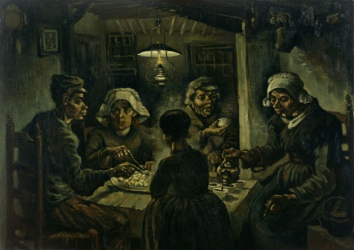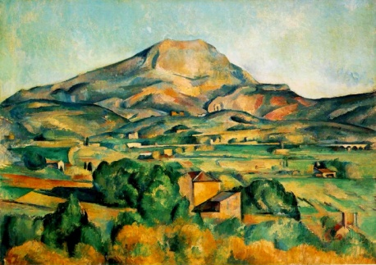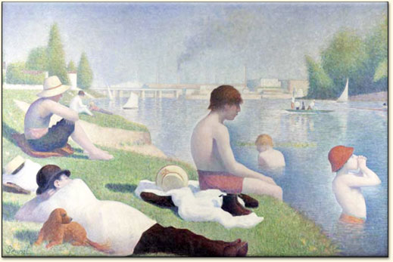

Potato Eaters - Vincent Van Gogh

Mt. Saint Victoire - Paul Cezanne

Bathers at Asinines - Seraut

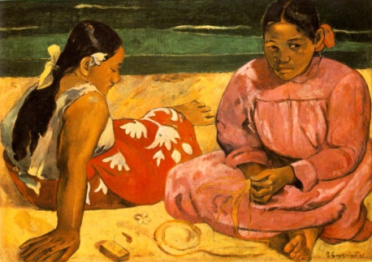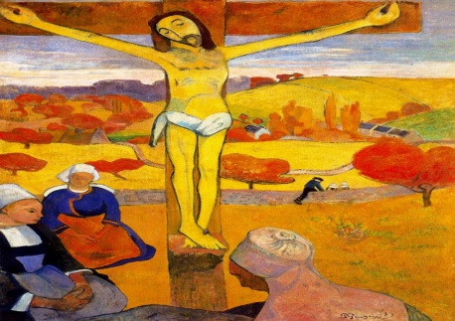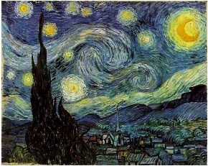

Tahitian Pictures - Primitivism - Paul Gaugin

Yellow Christ - Paul Gauguin

Starry Night - Vincent Van Gogh

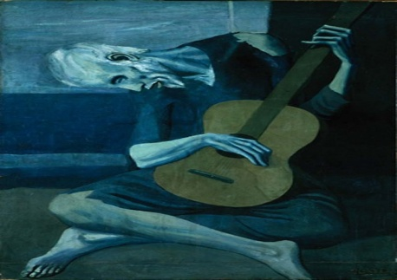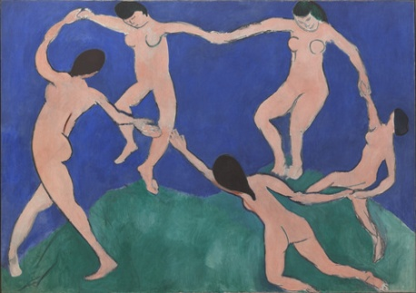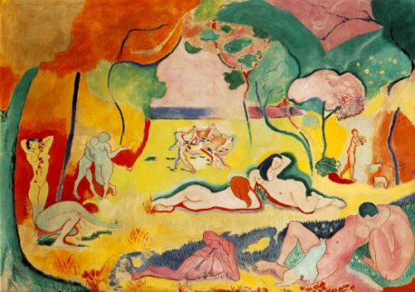

The Old Guitarist - Pablo Picasso

Dance - Henri Matisse

The Joy of Life - Henri Matisse

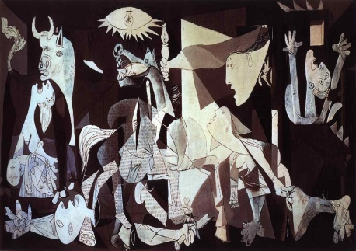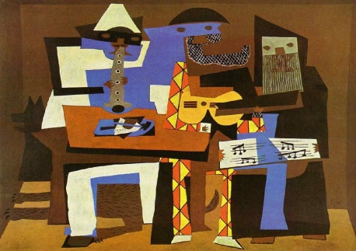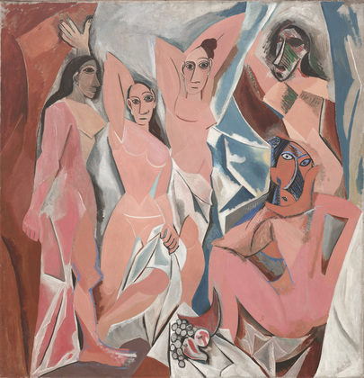

Guernica - Pablo Piasso

Three Muscians - Pablo Piasso

Les Demoiselles d'Avignon - Pablo Piasso

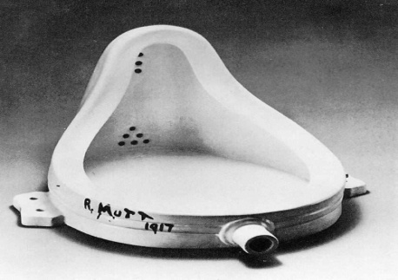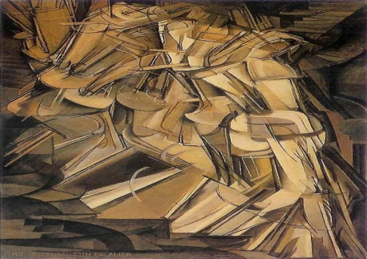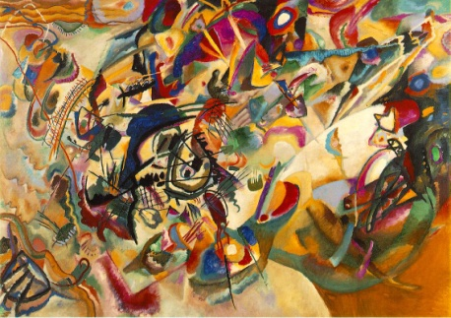

The Fountain - Marcel Duchamp

Nude Descending a Staircase - Marcel Duchamp

Composition VII - Wassily Kandinsky

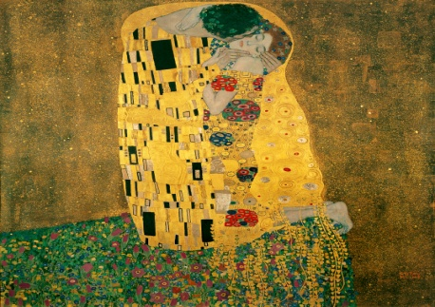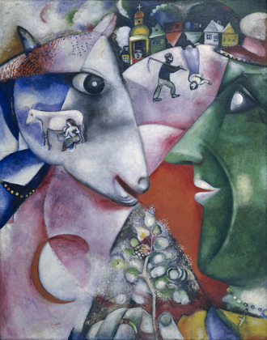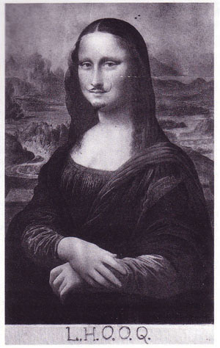

I and the Village - Marc Chagall

L.H.O.O.Q - Marcel Duchamp

The Kiss - Gustav Klimt

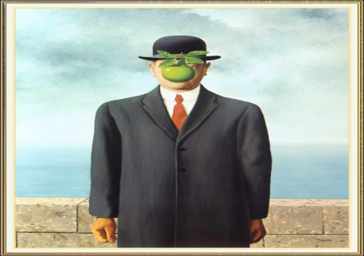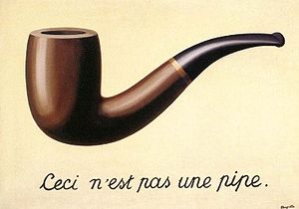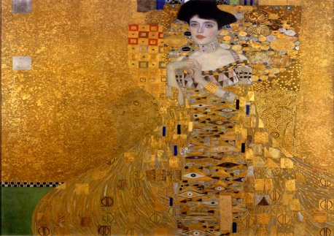

Son of Man - Rene Magritte

A Treachery of Images - Rene Magritte

The Portrait of Adele Bloch Bauer - Gustav Klimt

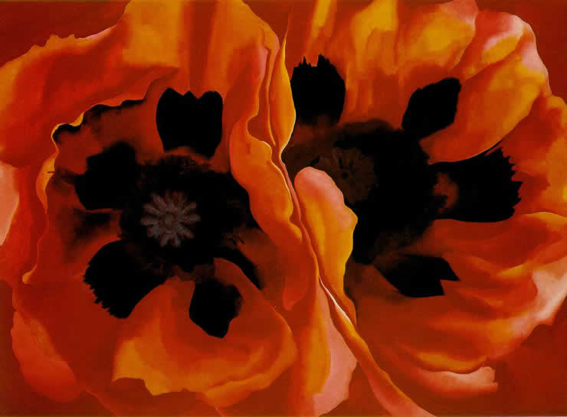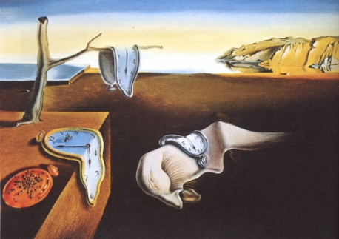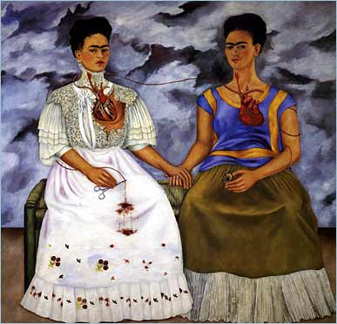

Oriental Poppies - Georgia O'Keefe

Persistence of Memory - Salvador Poli

The Two Fridas - Frida Kahlo

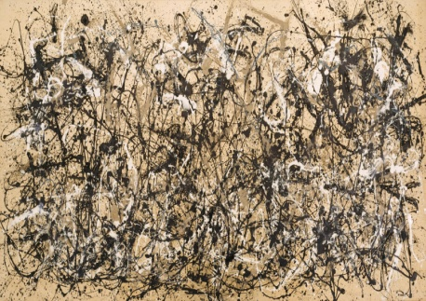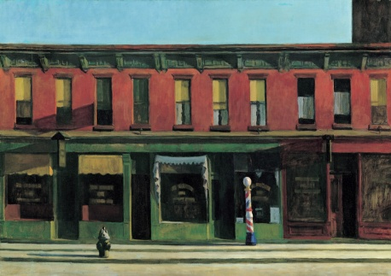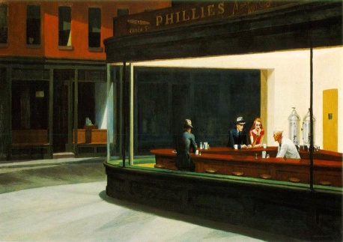

Autumn Rhythm - Jackson Pollock

Early Sunday Morning - Edward Hopper

Nighthawks - Edward Hopper

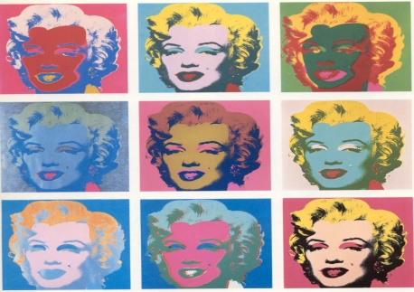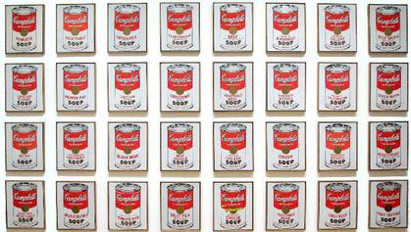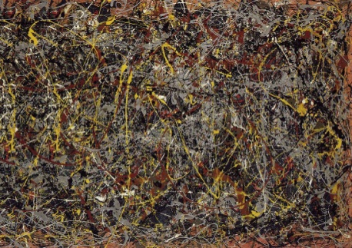

Marilyn Monroe - Andy Warhol

Campbell Soup Cans - Andy Warhol

Number 5 - Jackson Pollock

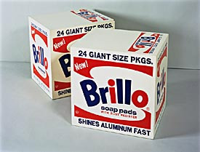

Brillo Boxes - Andy Warhol\

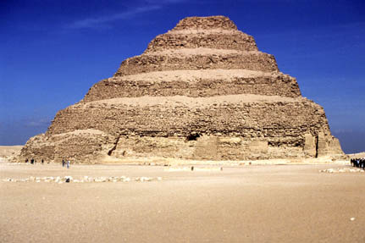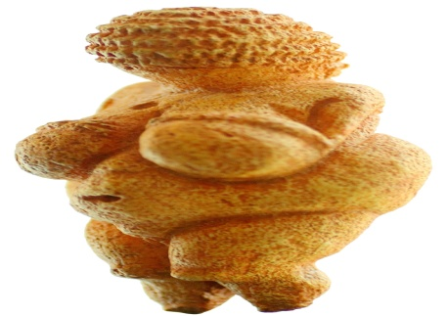Notes

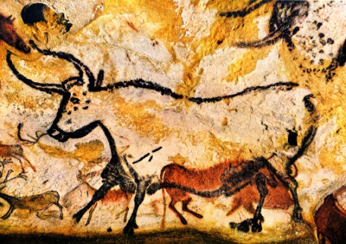

King Zoser Step Pyramid

Bison

Venus of Willendorf

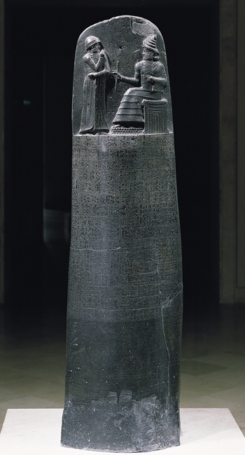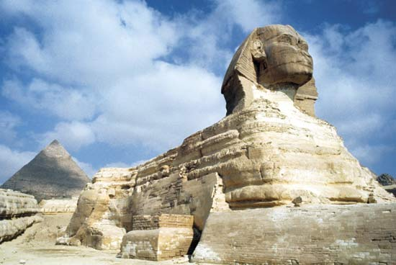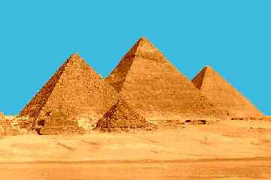

Stele of Hammurabi

Great Sphinx

The Great Pyramids

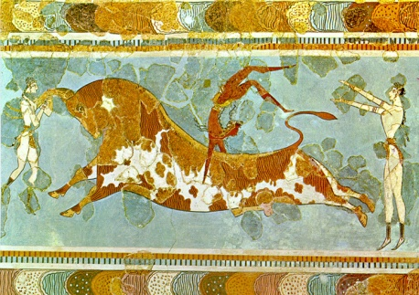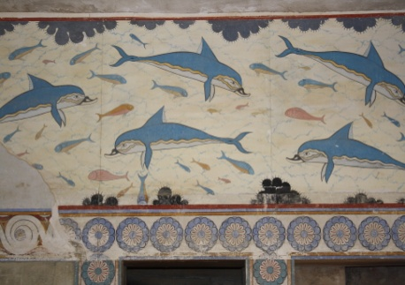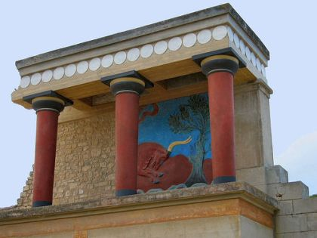

Bull Dance

Dolphin Fresco

Palace of Knossos

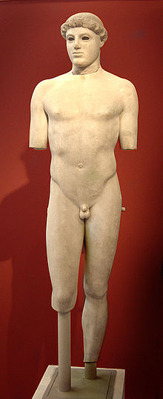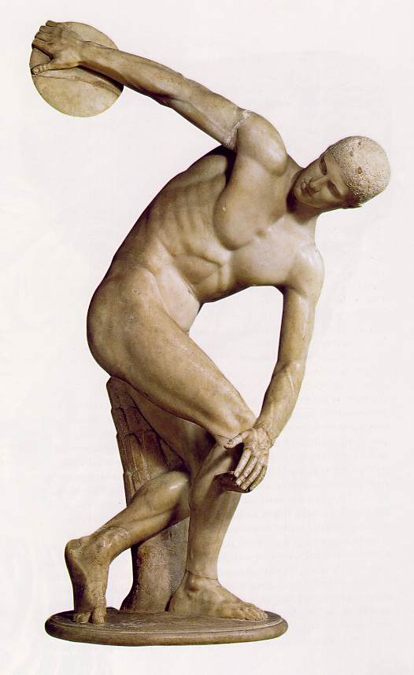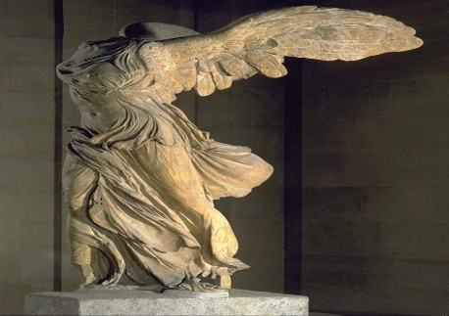  
  
  
  
  
  
  
  
  
  
  
  
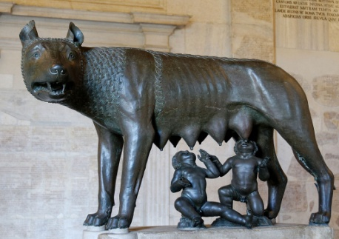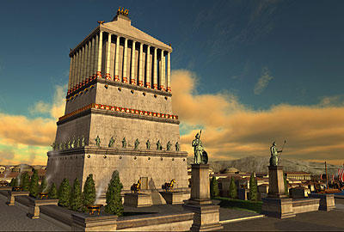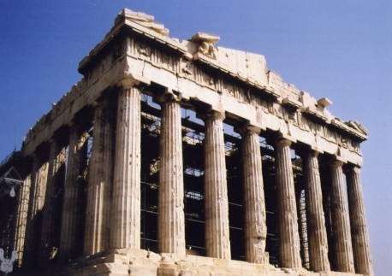

Nike of Samothrace (Winged Victory)

The Discus Thrower

Kiritios Boy

Pantheon

Baths of Caracalla

Coliseum

Pont du Gard

Vaults - Barrel, Groin

Arch with keystone and Voussoirs

She-Wolf

Mausoleum of Halicarnassus

Acropolis

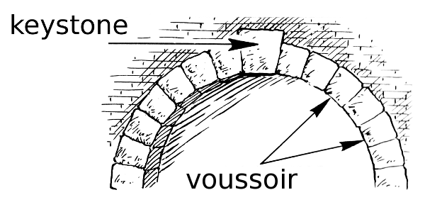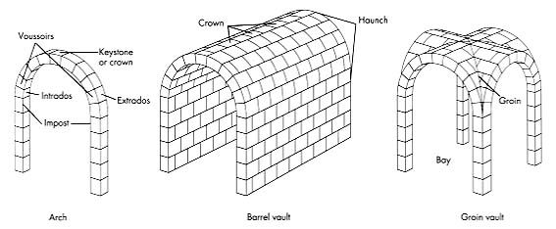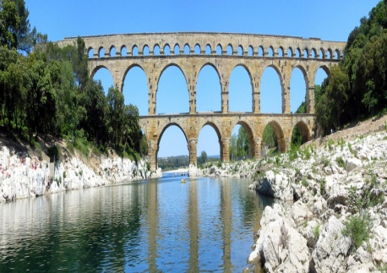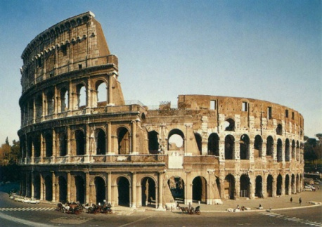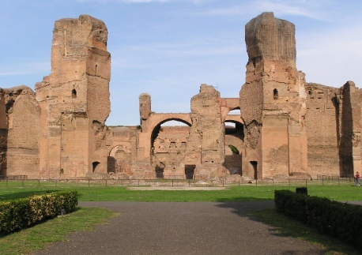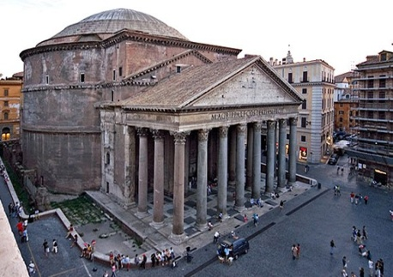

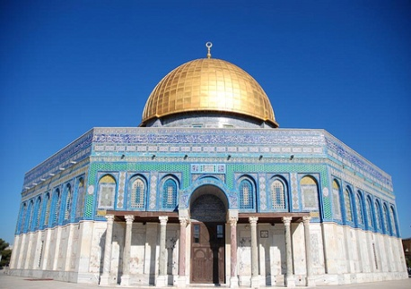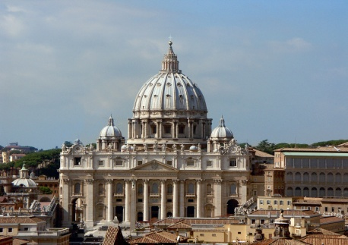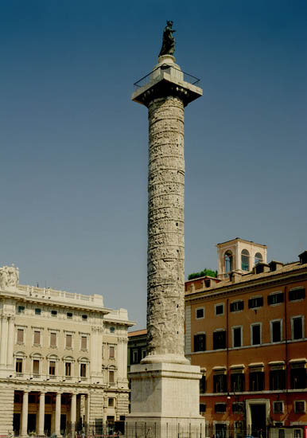

Dome of the Rock

Basillicas

Column of Trajan

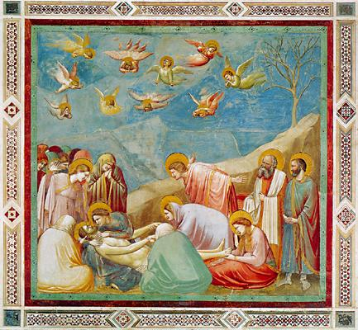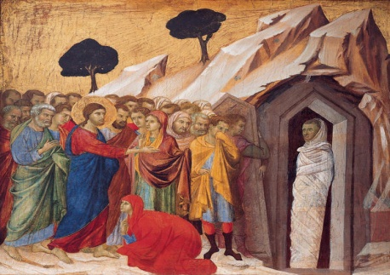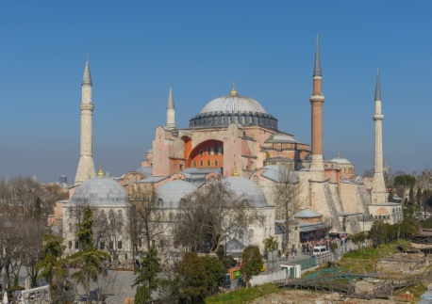

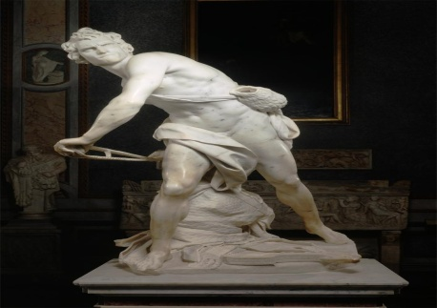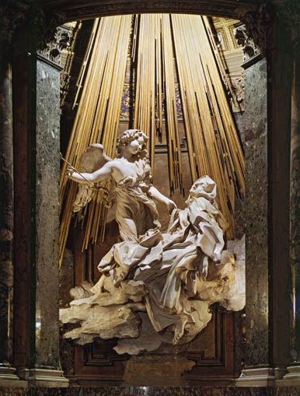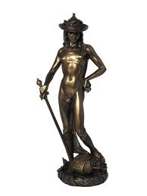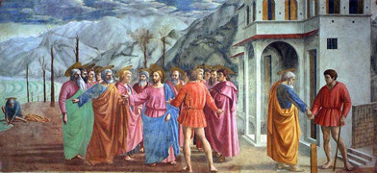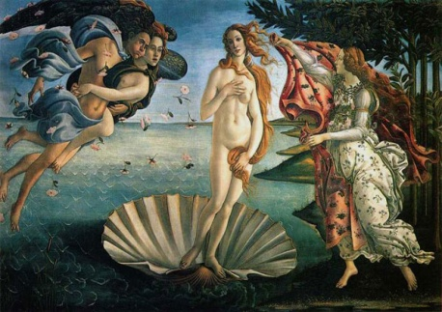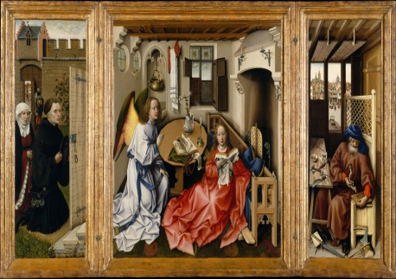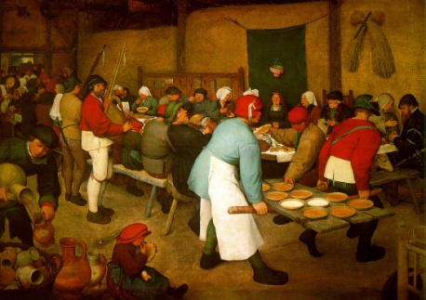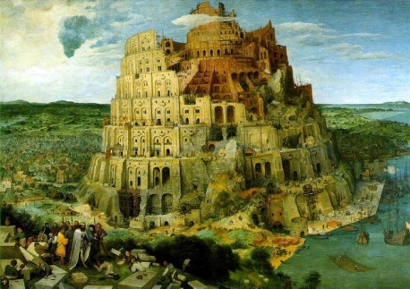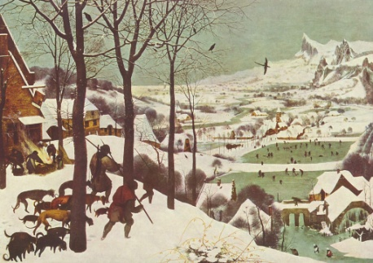  
  
  
  
  
  
  
  
  
  
  
  
  
  
  
  
  
  
  
  
  
  
  
  
  
  
  
  
  
  
  
  
  
  
  
  
  
  
  
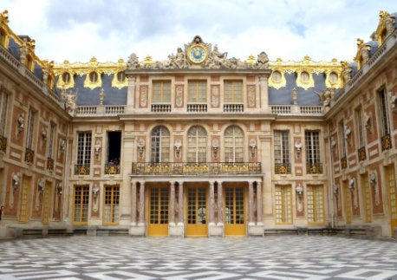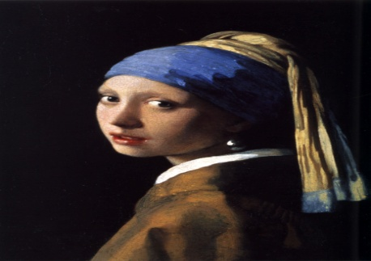

*David -* Bernini

*Ecstasy of St. Theresa -* Bernini

*Ambassadors* - Hans Holbein

*Tower of Babel -* Pieter Brugel

*Peasant Wedding -* Pieter Brugel

*Merode Altarpiece* - Robert Campin

*Birth of Venus* - Botticelli

*Tribute Money* - Massaccio

David - Donatello

Giotto - Lamentation

Duccio - Raising of Lazarus

Hagia Sofia

Palace of Versailles

*Girl with a Pearl Earring* Jan Vermeer

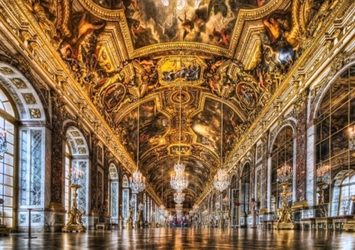

Hall of Mirrors - Palace of Versailles

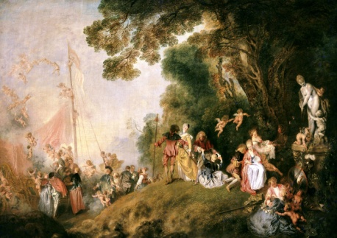

*Pilgrimage to Cythera* - Jean Watteau